405 Colorado - Austin, Texas
By Ian Conery

Developed by Brandywine realty, 405 Colorado is one of the latest additions to Austin’s rapidly changing skyline. Located next to the iconic Frost bank tower in the business district, 405 Colorado’s striking design features ten floors of office space and two vibrant levels of an outdoor skyspace, atop a strong masonry base of parking. It boasts a number of amenities throughout its 200,000 square feet, and a panoramic glass elevator with views of downtown.
It was designed by the same firm as its neighbor Frost bank tower, Duda-Paine Architects. Duda-Paine tried to maximize views and increase natural light in the building to be conscious of energy use. They made no attempt to hide the terra cotta colored parking podium, a choice many Austinites have found controversial. However, it reflects well structurally, with the lighter glass space atop holding offices, and the heavier more durable looking structure holding the cars below. But perhaps the most intriguing part of the building is the skyspace that lies in between the parking and office spaces, designed by STG Design. STG is an architecture firm who has worked on a number of stunning projects across Austin, including The Thinkery, UT’s Gates-Dell Complex, and most recently Google’s Block 185, and 405’s skyspace lobby is no exception.
The civil engineering work for the project was done by Stantec, a massive engineering firm that has worked on a number of buildings in Austin and around the world. The MEP work was done by Dallas firm Blum Consulting Engineers, Inc., who has designed the MEP systems for a majority of highrises in Austin. They were responsible for designing the storm drains to bring rainwater down the side of its complex shape to the storm systems at the street, as well as conceal each system within the building. Most notable concealed at the top level of the parking structure is a cistern which collects condensate from evaporators, which is then pumped into the cooling towers in the building. This system is a new requirement for all buildings in downtown Austin. The structure consists of a concrete vertical and lateral system designed by bdd Inc. It is well integrated throughout the building, with its columns neatly exposed at the skyspace level as well as in the floor lobby. Construction broke ground in March of 2019 by JE Dunn, a powerhouse contractor who has built a number of projects in Austin and nationwide. They completed work in late 2021.

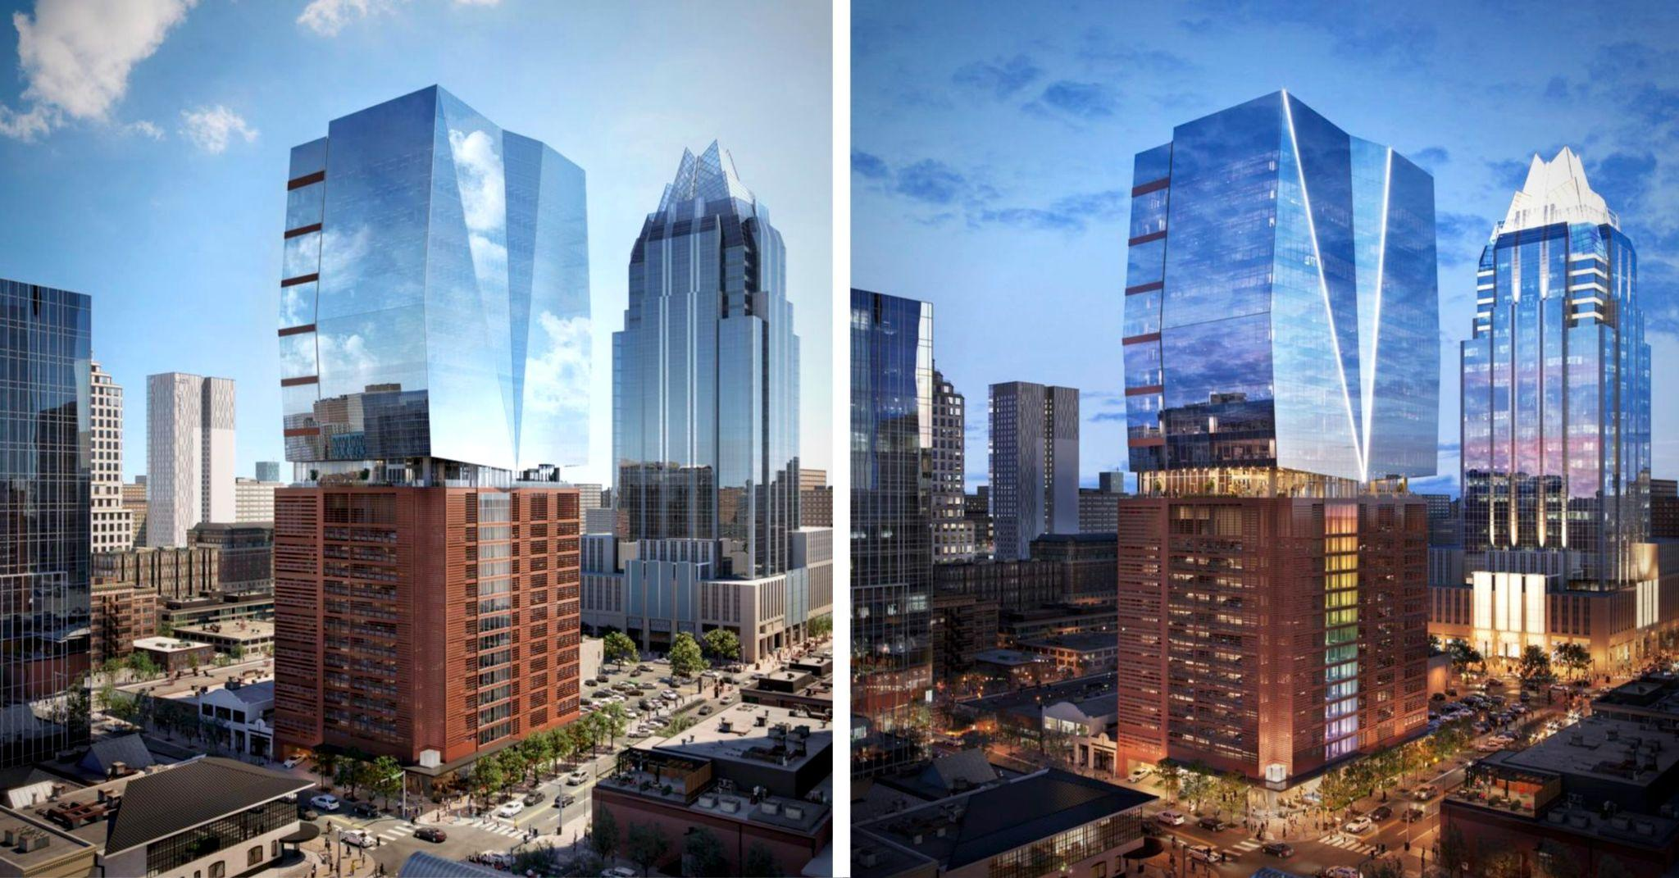
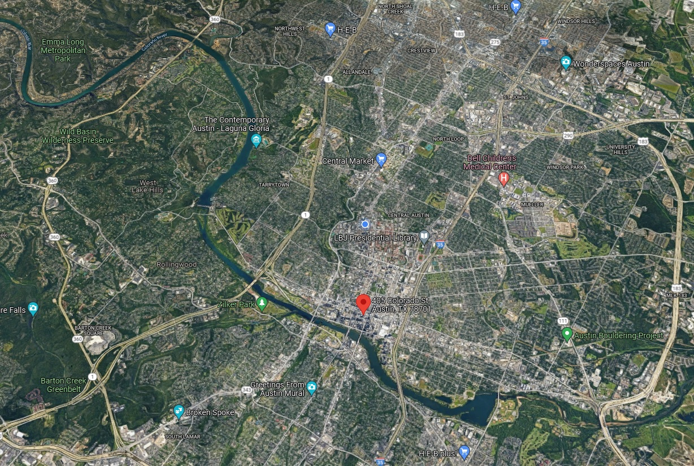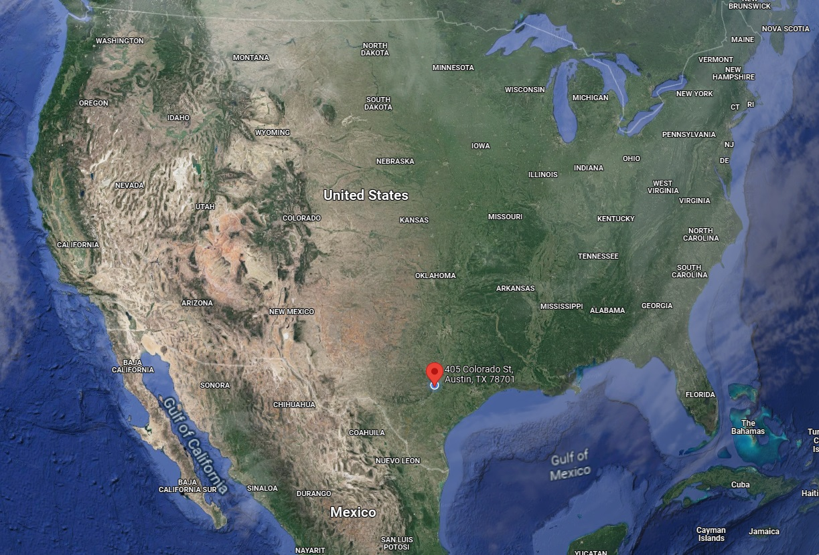

https://www.brandywinerealty.com/property/401-405-colorado-street
https://www.dudapaine.com/portfolio_page/405coloradotower/
https://austin.towers.net/in-defense-of-405-colorado/
https://stgdesign.com/projects
Phone call with Brennan Birchler P. E. of Blum Consulting Inc.

