Presence in Hormuz 2 – Hormuz Island, Iran
Essay by Sarah Dalby

Presence in Hormuz 2 is a community housing project designed by ZAV Architects, completed in 2020 on Hormuz Island in Iran. This project is a series of initiatives aimed at improving the economical and social quality of the island and country of Iran. This project is especially significant because of its emphasis on locality and sustainability. The labor force used in construction was restricted to locals and members of the community, which increased economic health and community buy-in. This intention also empowered workers by providing construction training and increasing the number of skilled laborers in Hormuz. The engineers used in the project also were native Iranians, and not global firms, which was important to keep even the technical aspects locally sourced. Additionally, only materials from Iran were used in the construction of the project, which increased the overall GDP of Iran and also decreased carbon emissions by sourcing materials locally. The soil was sourced from dredging the dock of Hormuz; yet another example of sustainable practices for this project.
The homes were constructed using a method called “superadobe”. This method utilizes “traditional earth architecture with contemporary global safety requirements”, including certain earthquake and weather regulations. The method is inspired by Iranian earth building methods and invented by Iranian American architect Nader Khalili. These buildings are created by filling long, tubular sand bags with soil and water, then connecting them into a circle. These circles are stacked one on top of the other as they are also decreasing in radius with each circle. This creates a dome-like structure and the outside and inside are sealed with plaster and an exterior treating. The homes on Hormuz were covered with plaster and painted vibrant primary colors, which are a nod to the colorful landscape of the island they reside on. This method of construction is easily repeatable, simple, and sustainable since it can utilize resources found on-site. There are also numerous energy benefits gained from the earthen walls, since the material used has a high thermal mass. This property allows the buildings to resist changes in temperature since the walls absorb and release heat very slowly.
This technology has the potential to greatly affect the future of sustainable buildings and lead to the futher development of net-zero buildings. This community style is significant for the field of urban development because of the flexibility of the site and the style of placement of the buildings, which lends itself to natural expansion. The actual rooms that are created by this architecture style are also extremely flexible, and can be outfitted as homes, community spaces, churches, laundry rooms, and more. This project is exceptional; not only because of its contribution to the architectural engineering field by combing natural building techniques and modern technology, but also by creating societal and economic change in a country plagued by hardship.
Bibliography:

Archilovers ArchiloversCom. “Presence in Hormuz 2: Zav Architects.” Archilovers, https://www.archilovers.com/projects/280210/presence-in-hormuz-2.html.

World Architecture Contents, WA. “ZAV Architects Built Colorful-Domed Housing Made of Rammed Earth and Sand on Hormuz Island, Iran.” World Architecture Community, World Architecture Community, 7 Dec. 2020, https://worldarchitecture.org/wa-top-teaser/egengzzh/zav%20architects%20built%20colorful-domed%20housing%20made%20of%20rammed%20earth%20and%20sand%20on%20hormuz%20island.

CalEarth “What Is Superadobe?” CalEarth, https://www.calearth.org/intro-superadobe.

Treehugger Marabito, Maria. “Are Adobe Houses Sustainable?” Treehugger, Treehugger, 15 Mar. 2021, https://www.treehugger.com/are-adobe-houses-sustainable-5116189.

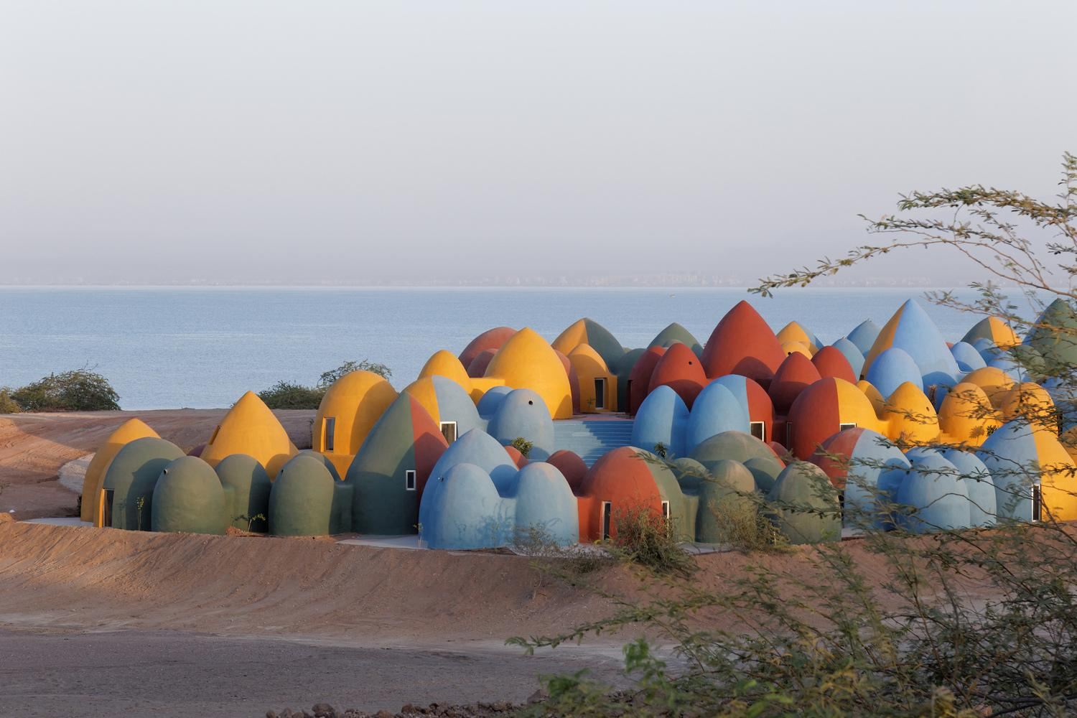

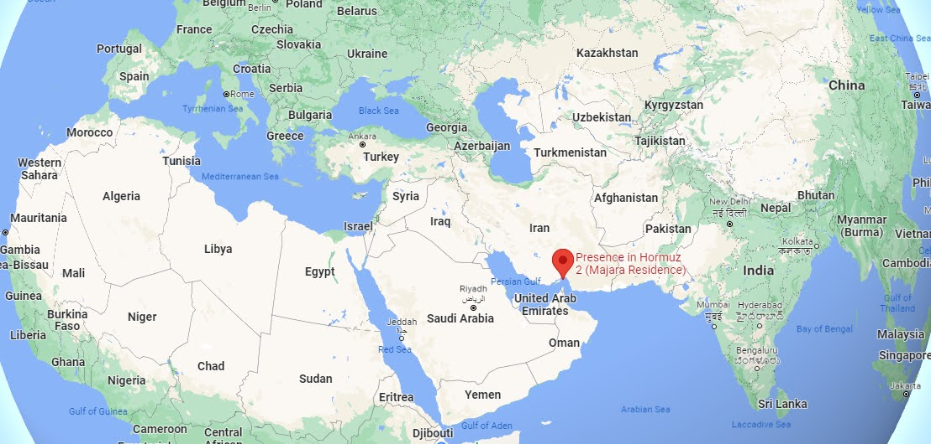

World Architecture
Archilovers
CalEarth
Treehugger

