International Towers - Sydney, Australia
By Ian Conery

International Towers Sydney, by Roger Stirk Harbour + Partners, stands nestled in the central business district on Sydney Harbour. It consists of three office towers, with a combined area of 3,056,000 square feet. Each tower responds to its unique geographic and environmental condition, along with the changing solar load throughout the day. This is achieved through the combination of solar shading, glass technology and thermal performance directly responding to context, orientation and solar path. The towers are oriented with long sides north–south to mitigate the impacts of the western sun.
The façades were designed by ARUP with very tight environmental targets. They use fixed external shading to minimise solar glare and load while acting as light shelves for daylight. They are tuned in slope and orientation to maximise view and minimise blind use. For the east and west façades, they include operable blinds for low angle sun conditions. This combination of outcomes was optimised for each individual panel. That is, each panel uses a specific set of shade and blind combinations to maximise daylight and view without exceeding peak thermal loads. This analysis was performed taking into account overshadowing of surrounding buildings, and as a result the shade subtly changes around the building in response to the tower’s unique microclimate.
Lendlease, whose headquarters are in tower 3, developed the project, as well as served as the contractor, quantity surveyor, and collaborating architect. They additionally designed the structural system with ARUP, and own towers 2 and 3. During construction, they targeted a 20% reduction in embodied carbon during construction, including a Life Cycle Assessment for the top 20 building materials and built their own concrete plant on site to save more than 300,000 truck movements and 5,000 tons of carbon emissions. It also ensured that 97% of all construction waste was recycled. Norman Disney & Young (NDY), a subsidiary of Tetra Tech, designed the MEP systems for the towers. Their design incorporated an active and passive chilled beam solution coupled with 100% fresh air, non-recirculatory supply air systems. International Towers won a number of awards in Australia, as well as achieving a 6 star rating from Australia’s environmental certification, Green Star, and a Platinum rating from the WELL Certification.

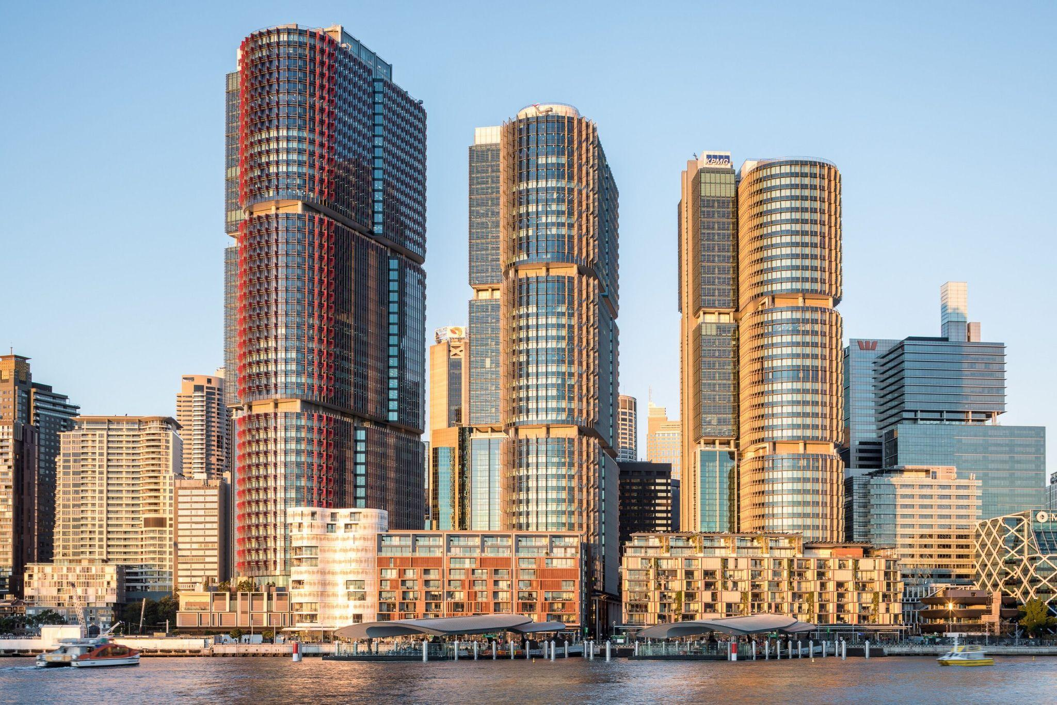
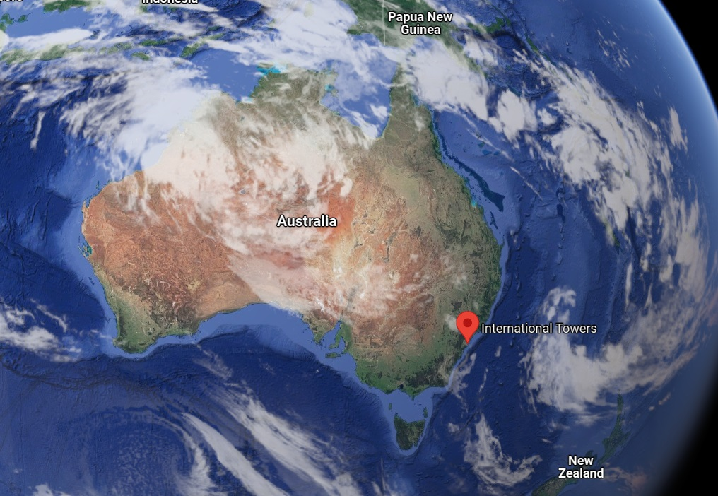

https://www.rsh-p.com/projects/office/international-towers-sydney/
https://www.arup.com/perspectives/beneath-the-surface-of-high-performance-facades
https://ndy.com/experience/international-towers-sydney

