Telus Stadium

Telus Stadium at Universite Laval in Quebec City is indicative of the growing movement of mass timber construction. Completed in 2011, the stadium was built as part of an effort to expand the university’s athletic facilities, known as PEPS. Located next to an existing outdoor stadium, Telus Stadium houses a 100 m x 60 m synthetic grass field that is used for soccer and rugby games, as well as football practices. 452 seats, locker rooms and food concessions line the interior perimeter of the stadium. It also has facilities and infrastructure for media broadcasting.
The stadium features glulam (glue laminated) wood construction for the majority of the structural frame. The roof is spanned by thirteen 67.6 m arches made from black spruce, as well as glulam joists spanning perpendicular to the arches. Connections between arches and joists are made from both wood and steel. Each of the arches terminates with a concrete connected joint that uses steel dowels and self-tapping screws. Steel tubing also connects the perimeter of the roof to the same concrete joints, allowing for all loads to be terminated in the same location. This is not only structurally efficient, but aesthetically highlights the binary construction of steel and wood being used in tandem.
Each glulam piece was pre-fabricated, allowing for quick erection of the stadium’s structure, as well as work to continue in the winter. This is an advantage to concrete construction which has major struggles in being placed in the winter, and oftentimes cannot be placed at all in places such as Quebec where Telus Stadium resides. Pre-fabrication of pieces such as arches also allows for better quality control, as natural materials such as wood can be wrought with imperfections.
Along with its structural capabilities, the glulam wood used also has a very green benefit. The choice to use wood saves the project approximately 1,500 tons of CO2 during the construction process. The roof of the stadium also features reflective tiles that help in minimizing the cooling cost in the summer when days are long at the latitude the stadium is located.
The Telus Stadium stands as an example of forward thinking architecture and engineering at an attainable level. With a budget of $26 million, Telus stadium is certainly not cheap, but is indicative of a conscious trend toward sustainable design at a more practical level.

https://www.abcparchitecture.com/en/projects/architecture/telus-stadium
http://www.fgp.ca/portfolio/stade-telus-du-peps-de-luniversite-laval/
https://www.thinkwood.com/projects/stade-telus-universite-laval-stadium
https://www.coarchitecture.com/stade-telus
https://www.nordic.ca/en/projects/structures/laval-university-telus-stadium

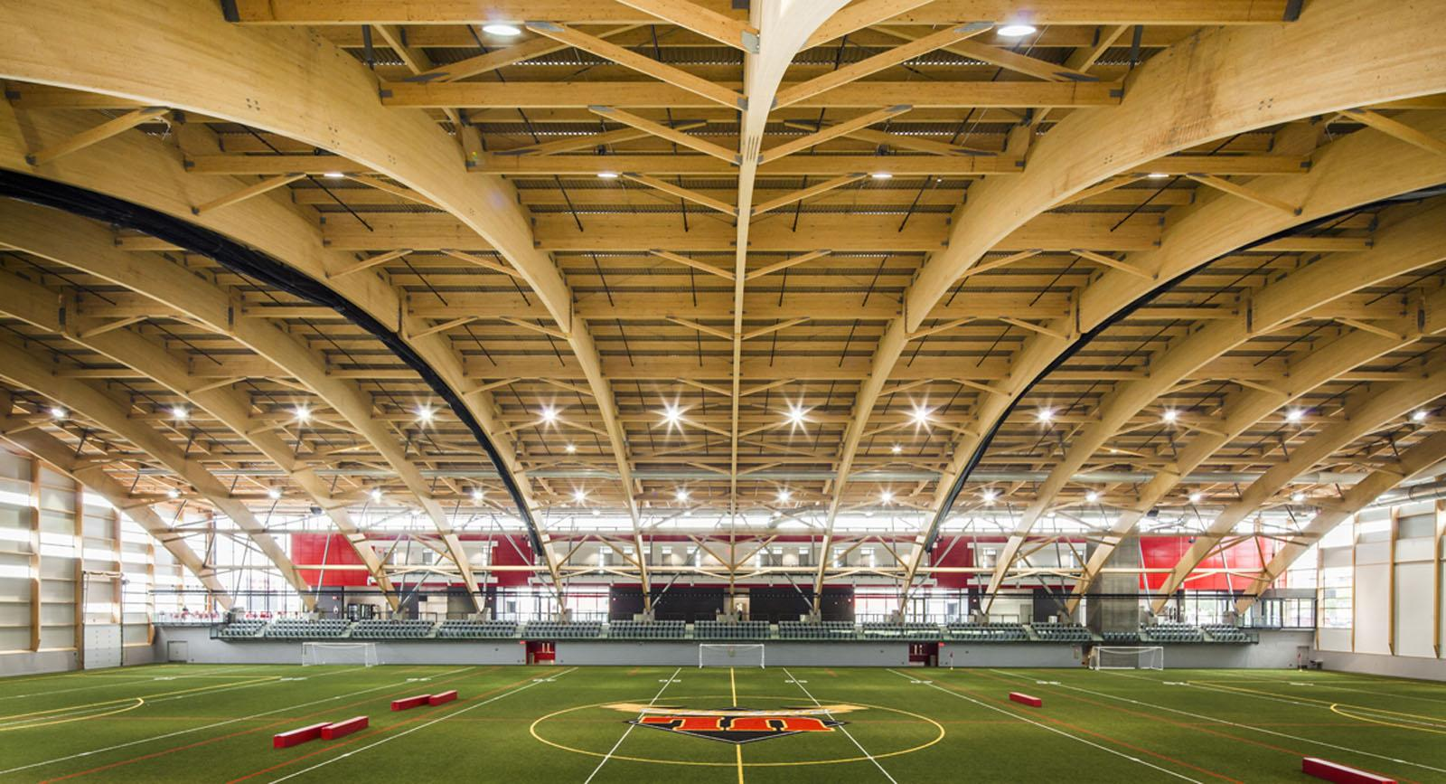

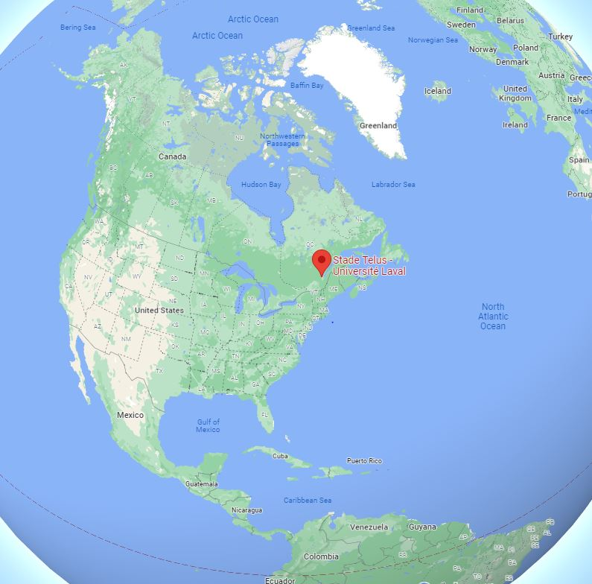

Think Wood
FGP
Think Wood
Coarchitecture
ABCP

