UBC Pharmaceutical Sciences Building

The University of British Columbia's Pharmaceutical Sciences Building is a 246,000 sq. ft. facility opened in 2012 that was built to expand the capabilities of the School of Pharmacy and allow for more students to be graduated. The building achieved LEED Gold status for its energy and water efficiency, along with the number of recycled and local materials used in its construction. The facade of the building features cantilevered glass boxes that are the focal point of any onlooker. The building stands as the crown jewel of the School of Pharmacy and as a noteworthy piece of architecture at the highly regarded University of British Columbia.
The most obvious feature of the building is its cantilevered glass boxes that extrude at various depths. Containing offices and conference rooms, the light live loading allowed for concrete slabs of only 250 mm thickness to be used which connect to hidden concrete columns allowing for the cantilevers to exist. These cantilevered spaces sit above a ground floor consisting of glass and architectural concrete, which gives the whole building the appearance of being cantilevered. This is not the case as there are two exposed columns that sit at the entrance, however they hold a considerable tributary area above them, made possible again by the aforementioned thin slabs.
The building also boasts an impressive plumbing system. Using capture and filtration systems, the building is able to use rainwater in its plumbing system, allowing for a 20% reduction in potable water consumption. The system also features low-flow fixtures and automated sensors to only use water when necessary. Along with water saving measures, the building is also equipped with Containment Level 2 Biosafety requirements.
Splitting the building into thirds, two atria bring in a wealth of daylight and features interior finishing with an abundance of Western Red Cedar wood. By using this locally sourced material, construction costs were able to be lowered. Additionally, 94% of the construction waste was recycled or salvaged. These atria also act as zones of high air circulation and mixture, and being centrally located, is able to help maintain a consistent temperature more efficiently. The indirect daylighting also assists in lowering heating costs in the summer months.

https://news.ubc.ca/2012/09/18/ubc-opens-new-133m-pharmaceutical-sciences-building
https://pharmsci.ubc.ca/about/facilities/about-our-building
https://www.stantec.com/en/projects/canada-projects/u/university-of-british-columbia-faculty-of-pharmaceutical-sciences-centre-for-drug-research-and-development
https://www.naturallywood.com/project/ubc-pharmaceutical-sciences-building/
https://glotmansimpson.com/project/ubc-faculty-of-pharmaceutical-sciences/
https://www.ledcor.com/our-projects/building/institutional/ubc-pharmaceutical-sciences-building

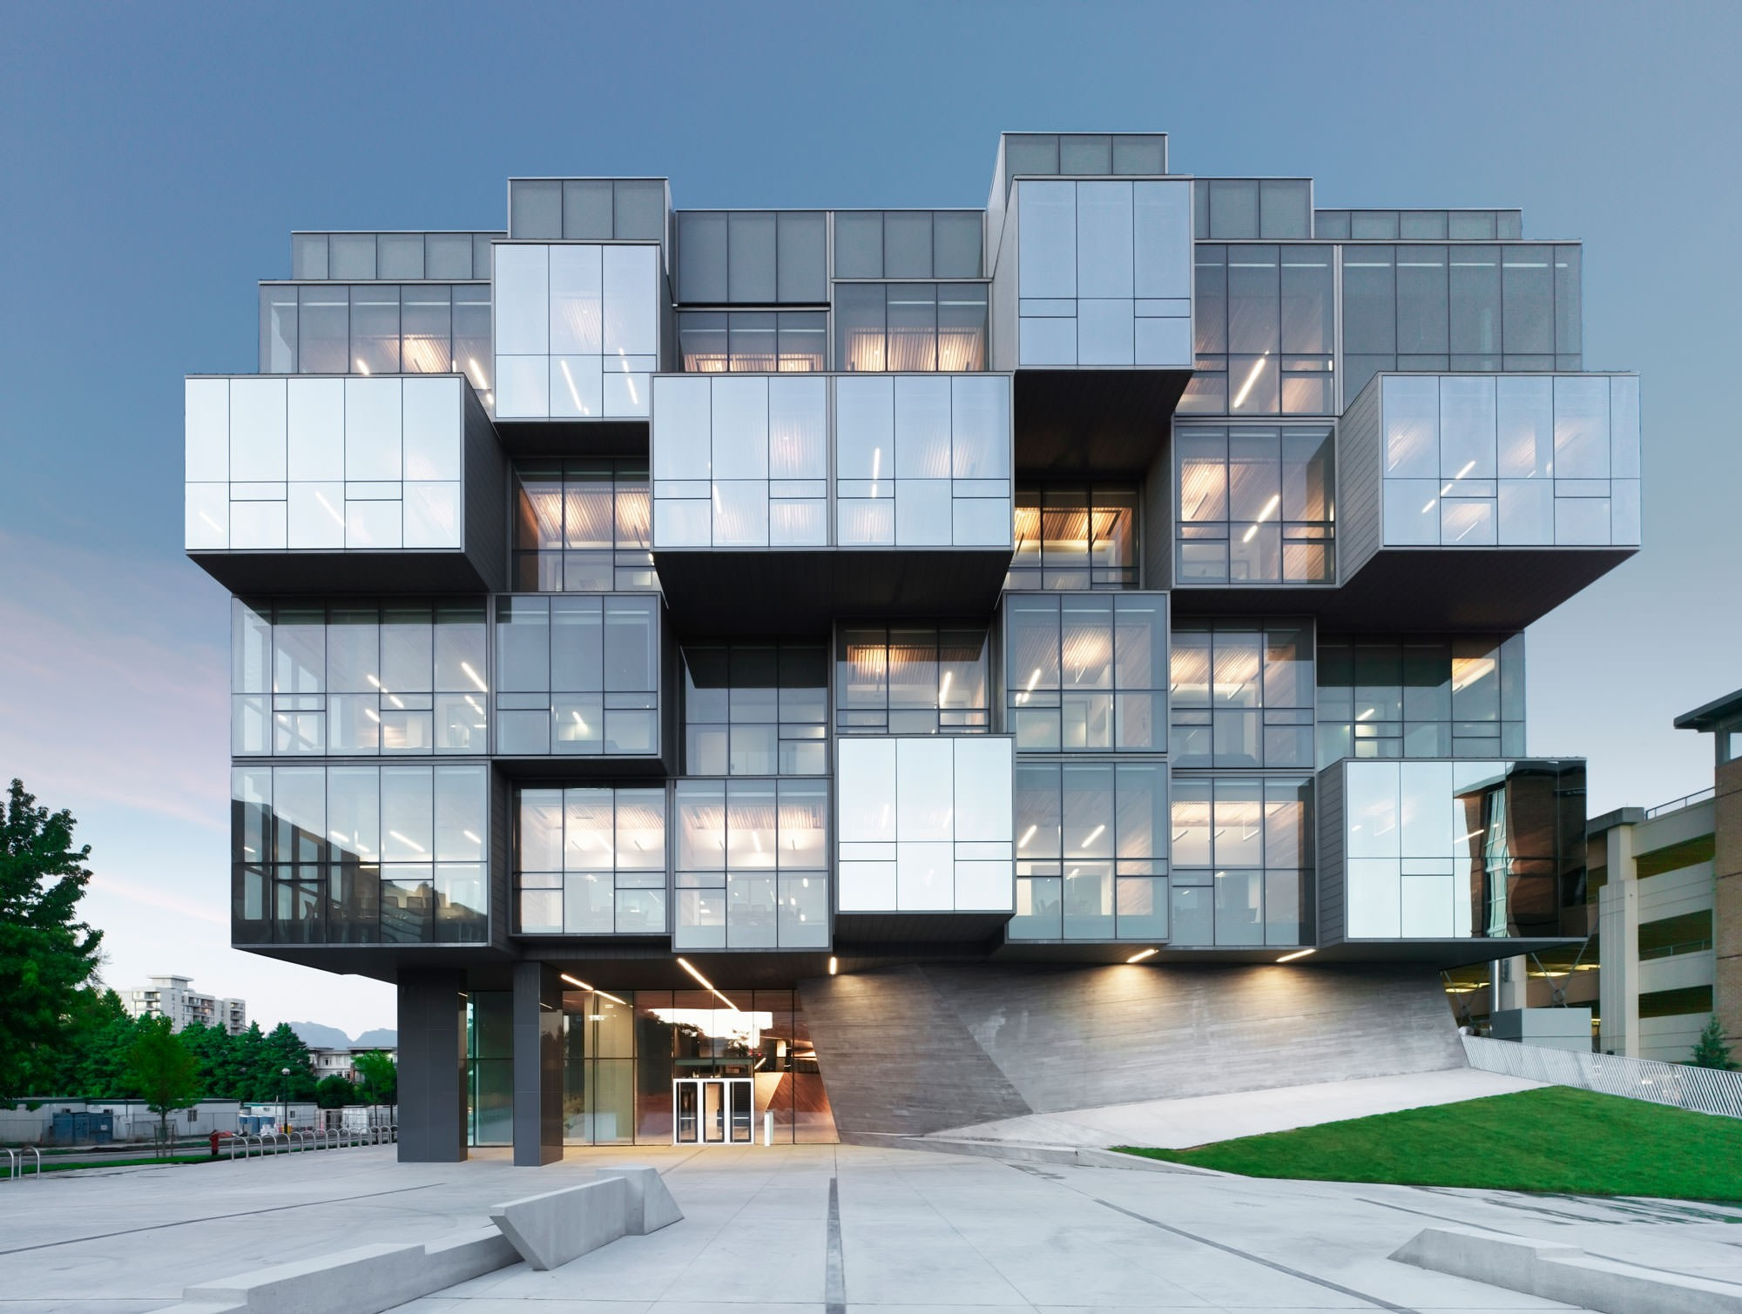

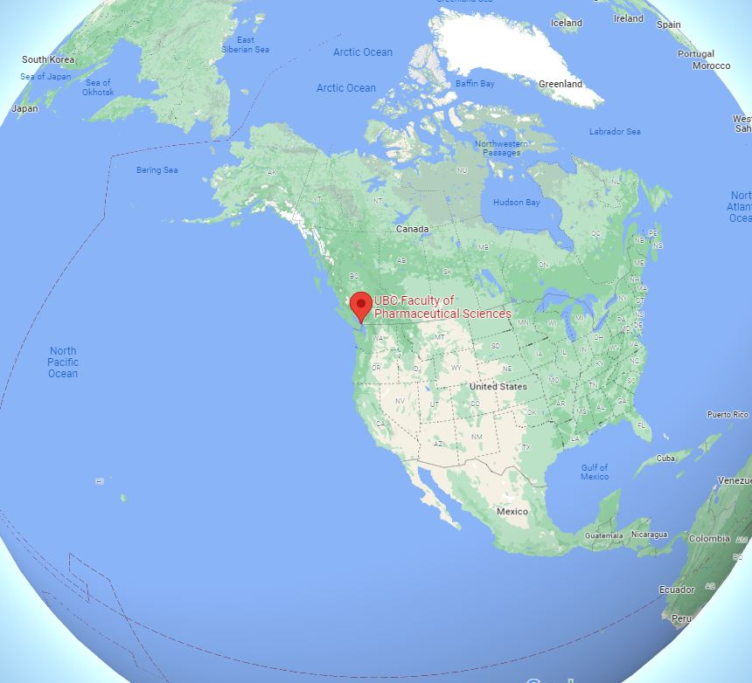

UBC
Glotman Simpson
UBC
Stantec
Naturally Wood
Ledcor

