Saemoonan Church - Seoul, South Korea
By: Peter Baillo

Saemoonan Church, designed by Seoinn Architects in collaboration with KOMA, is a modern-day reinterpretation of religious architecture. Located in Seoul, South Korea, the church was completed in 2019 and is the newest chapel developed by the Saemoonan Church ministry. With 13 stories above ground and 6 stories below, the entire building area comes out to 2,452.6 square meters and 67.93 meters high.¹
Construction and design of the church centered on the theme of love for God and love for the neighbor. To express this, complex geometry was used in the form of curvature. The love of God was portrayed by having the front of the building curve into a U-shape. The space formed by the U-shaped facade metaphorically expresses God’s love and mercy through the smooth, soft, curved surface that gives the illusion of God’s embrace.² Construction of this curved facade first started by dividing the rectangular site into three. Of the three divisions, the middle of the three was designated as where the curved facade will be constructed. Using a steel frame as the basis of the structure, construction started from the bottom to the top. When the structural frame for the first few floors were done, construction then moved onto the basement and the lower six floors. Reinforced concrete was then used in this phase of construction and the influence of curvature can be seen in the low floor designs as the floors started to mimic the style of the facade. After the lower floors were completed, the ground floor and the upper floors were then worked on. The structural engineers adopted cross-bracing as the main lateral support method of the church. Due to the lower floors being completed first, the structural component of the curved facade was mostly completed with the exception of the curved steel beams necessary to make a curved facade. Once the curved steel beams were installed, construction on the curved facade began. Intentionally made hollow, the curved facade starts from the bell tower and gradually makes its way up to form a curved spire, replacing the conventional Gothic spire seen in other church facilities.³ The facade is made out of concrete but uses wasabi stone as an exterior finish, an incredible feat considering how difficult it can be to make granite curved. Furthermore, the exterior finish of the facade is incredibly smooth showing the level of artistry used on the granite. ⁴
Besides Seoinn Architects and KOMA, other consultants involved in the construction and design of Saemoonan Church are The Naeun Structure Corporation, responsible for the structural design of the church, and CJ Construction Co., responsible for the construction of the church. Mec & MC Co. was responsible for the mechanical design while Daekyung Electric Co, was responsible for the electrical design. Saemoonan Church also received the Architecture MasterPrize under the Cultural Architecture category.⁵

Bibliography:
¹ https://vmspace.com/project/project_view.html?base_seq=OTI0
² https://www.dezeen.com/2019/10/02/saemoonan-church-seoinn-design-group-seoul/
³ https://www.facebook.com/watch/?v=1311315755588523
⁴https://m-blog-naver-com.translate.goog/tallname/221812222484?_x_tr_sl=ko&_x_tr_tl=en&_x_tr_hl=en-US&_x_tr_pto=wapp
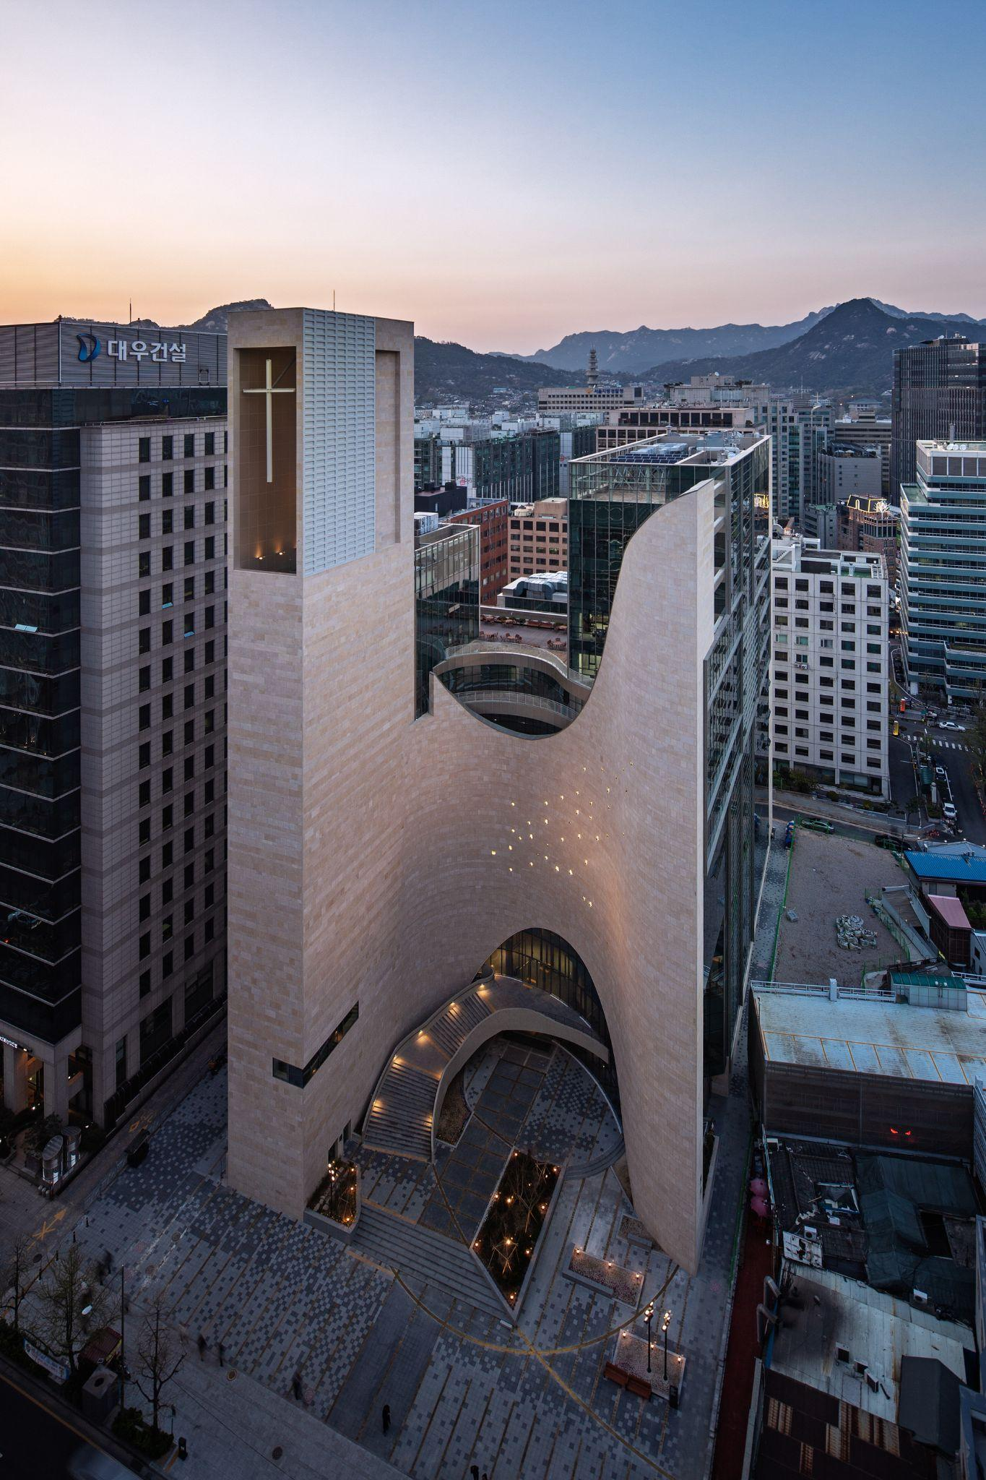
⁵ http://www.koreaherald.com/view.php?ud=20191003000104
