Saxon State and University Library – Dresden, Germany
Grant Miller

Before the 1990s, precious knowledge and resources were scattered about the city of Dresden. The planned merging of two large libraries—the Saxon State Library and the University Library—would change this. For this historic consolidation, the City of Dresden held an open design competition. Over 200 architects and firms submitted their vision for the grand library.
In 1996, German-Austrian firm Ortner & Ortner, headed by Laurids and Manfred Ortner, won the design competition. Their two-towered approach would pay proper tribute to the new Saxon State and University Library, “a library of European importance.” Built on top of a football field at TU Dresden, the library was completed in 2002 at a cost of 3.25 million Euros.
The number two is the backbone of the library, often abbreviated as the SLUB Dresden. There are two towers neatly reflected across a central park; two spaces, one insulated below ground and one open to the world above; and two conflicting styles. A rational Neoclassical style is apparent in the regal towers, whose rectilinear geometry betray a firm foundation of knowledge for the future. Yet the irregular window placement, and sleek but stylized travertine façade, are contributions from more recent design movements. The façade of each tower is notched with rectangular grooves resembling books stood up on a shelf. Piercing the green lawn, the towers are display shelves inviting the world into their priceless collections.
As for the interior, the library is a circulatory system, with the impressive reading atrium as its heart. After entering through a colonnade at the western tower, visitors are naturally directed to this central space, at which all passageways start and terminate. Three stories tall and with a glass crown, this room allows the scholars of SLUB Dresden fresh air. Footbridges and hallways lead guests toward quieter and more introspective spaces, including into more specialized spaces in the towers. In the past decade, the library has greatly expanded its digital resources and now boasts maker spaces for various creative projects.
A 2008 study from TU Dresden analyzed the effect of architectural choices on user experience in libraries. Referencing surveys of visitors, it considers SLEB Dresden a “place of silence and concentration,” whose structured layout encourages introspection and self-engagement.
Sources
Guggenheim, Michael, and Heinz Egger. “SLUB, Dresden (Germany).” Buchort, https://buchort.ch/slub-dresden-d/, accessed 9 November 2022.
Richter, Peter G., Michael Dufter & Maria Seeliger. “Effects of Building Aesthetics and Symbolism on Experience and Behaviour in Libraries.” TU Dresden, https://www.architekturpsychologie-dresden.de/downloads/poster_berlin_english.pdf, accessed 9 November 2022.
“Sächsische Landes-, Staats- und Universitätsbibliothek S.L.U.B. Dresden.” O&O Baukunst, https://ortner-ortner.com/de/baukunst/projekte/kultur/slub-dresden, accessed 6 November 2022.
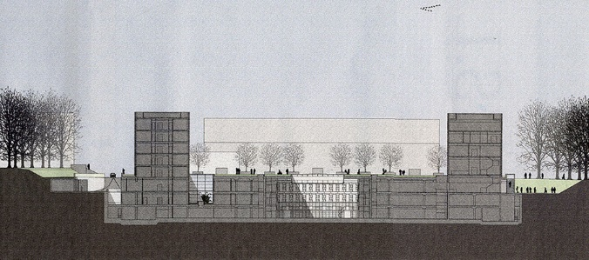
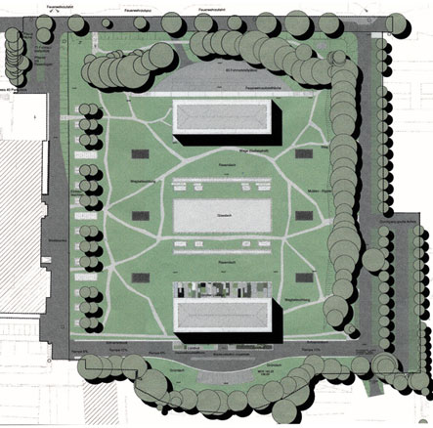
“SLUB - Saxon State and University Library Dresden.” Das Neue Dresden, http://www.das-neue-dresden.de/slub.html, accessed 8 November 2022.
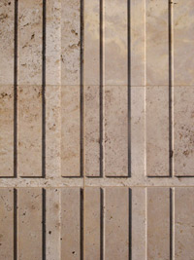
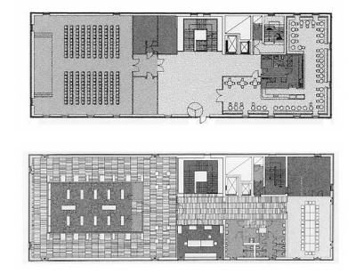
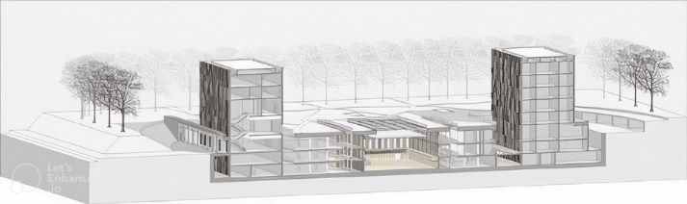
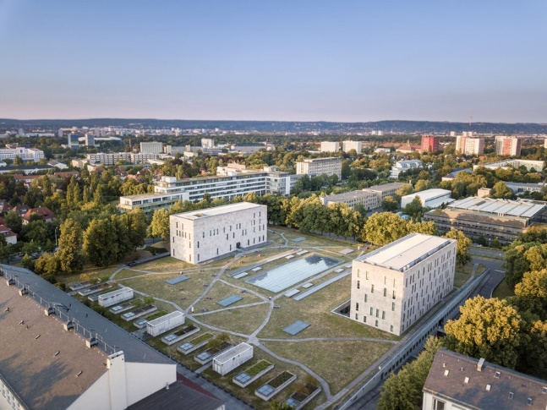
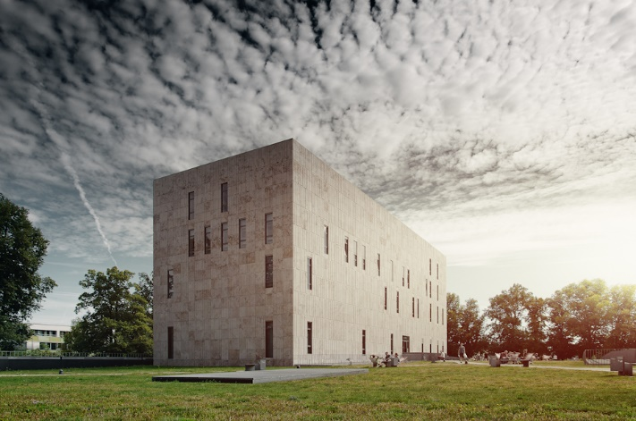
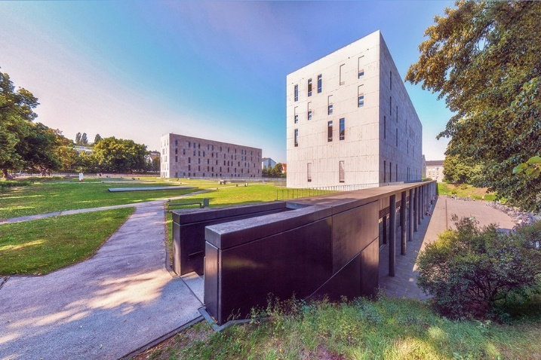
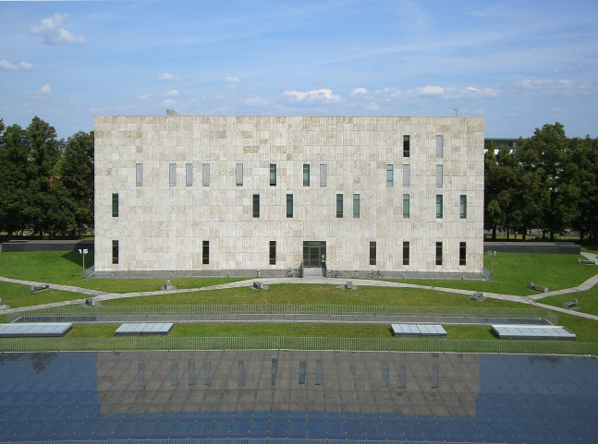

Image Sources
https://ortner-ortner.com/de/baukunst/projekte/kultur/slub-dresden
https://tu-dresden.de/studium/im-studium/studienstart/infomarkt/aussteller-infomarkt/zentralbibliothek-slub?set_language=en
http://coquimalachowskacoqui.com/de/lesepark-der-sachsischen-landes-staats-und-universitatsbibliothek-dresden-realisiert-2.html
https://www.flickr.com/photos/slubdresden/17929084102/in/photostream/
https://www.flickr.com/photos/durr-architect/8517682865/
https://www.flickr.com/photos/meyerfelix/7892432774/in/photostream/
https://www.tumblr.com/thearchitecturalsite/159367004689/ortner-ortner-saxon-state-and-university

