Toranomon-Azabudai - Tokyo, Japan
Essay Generated By ChatGPT, verified and edited by Martin Rodriguez
Heatherwick Studio's Pergola at Toranomon-Azabudai is a striking piece of public art and architecture that is a highlight of the larger Toranomon-Azabudai development project led by Mori Building Co. Ltd.. The Pergola is a sculptural piece that is intended to serve as a sheltered gathering space within the bustling city, providing visitors with a peaceful oasis in the heart of Tokyo.
The design of the Pergola is inspired by traditional Japanese architecture with a contemporary twist. The structure consists of a series of arches made of polished steel arranged in a grid pattern that creates a sense of rhythm and movement. The arches support a roof that allows natural light to filter through while providing shade and protection from the elements.
The Pergola also includes a variety of planters and seating areas, creating an inviting and relaxing space for visitors to enjoy. The design team worked closely with horticulturalists to select plants that would thrive in the conditions of the space, creating a lush and vibrant environment that enhances the beauty of the Pergola.
The design of the rooftop garden is intended to create a lush and vibrant environment that enhances the beauty of the building and provides a natural space for building occupants and visitors to enjoy. The garden will also help to improve the building's environmental performance by providing insulation, reducing the heat island effect, and improving air quality. The plants that will be used on the top of Heatherwick Studio's Toranomon-Azabudai building are likely to be carefully selected to create a beautiful and sustainable environment that enhances the overall design of the building while also providing important environmental benefits.
Heatherwick Studio's building in Toranomon-Azabudai is still under construction and not yet complete, but we do have some details about its design based on the released plans and renderings.
The building is composed of three towers that are connected by a central courtyard. The towers have a unique undulating shape that resembles natural rock formations. The facade of the building is made up of thousands of diamond-shaped glass panels, which create a reflective surface that interacts with the surrounding environment.
Inside the building, there will be a mix of office spaces, residential units, and retail spaces. The central courtyard will serve as a public space, with gardens, water features, and seating areas for visitors to enjoy.
The design of Heatherwick Studio's pergola in Toranomon-Azabudai is intended to create a distinctive and engaging environment that blurs the boundaries between the building and the natural world. It is a highly anticipated project that is expected to become a significant landmark in Tokyo's skyline.
Overall, the design and construction of Heatherwick Studio's Pergola at Toranomon-Azabudai was a remarkable achievement that demonstrates the power of innovative design and technical expertise. The Pergola is a unique and memorable piece of public art that adds a new dimension to the urban environment of Tokyo, creating a space that is both beautiful and functional and providing visitors with a sense of peace and tranquility in the heart of the city.
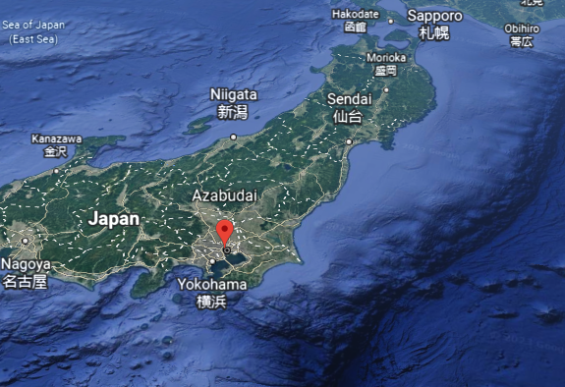

Essay Prompt: Write a 500 word essay over Heatherwick Studio's Pergola at teranomon-azabudai, and its design and construction process

Have you heard of Toranomon-Azabudai
Yes, Toranomon-Azabudai is a development project in Tokyo, Japan that is being led by the real estate company, Mori Building Co. Ltd. The project is located in the Minato ward of Tokyo and is expected to be completed in the early 2020s. It is a large-scale development that includes the construction of office buildings, residential towers, retail and commercial facilities, and public spaces. The aim of the project is to create a new urban center that integrates various functions and enhances the livability and sustainability of the city. The project has received a lot of attention in Japan and internationally, and is expected to become one of the most significant urban developments in Tokyo in recent years.

Have you heard of Heatherwick Studio's building in Toranomon-Azabudai
Yes, I am aware of Heatherwick Studio's building in Toranomon-Azabudai. The building is called "Toranomon-Azabudai Project," and it is a part of the larger Toranomon-Azabudai development project led by Mori Building Co. Ltd. The building was designed by the British architecture and design firm Heatherwick Studio, which is known for its innovative and unconventional approach to architecture.

The Toranomon-Azabudai Project building is a mixed-use development that includes offices, residences, and commercial spaces. The building is composed of three towers that are connected by a central courtyard. The towers are designed to resemble natural rock formations, and the facade is made up of thousands of diamond-shaped glass panels that reflect the surrounding environment.

The building has received a lot of attention for its unique design and is expected to become a significant landmark in Tokyo. It is currently under construction and is scheduled to be completed in the early 2020s, along with the rest of the Toranomon-Azabudai development project
What engineers worked on Heatherwick Studio's Toranomon-Azabudai project
As an AI language model, I don't have access to information on the specific engineers who worked on the Toranomon-Azabudai project with Heatherwick Studio. However, it's common for architectural projects of this scale to involve a multidisciplinary team of professionals, including structural engineers, mechanical engineers, electrical engineers, and other specialists.
Heatherwick Studio is known for its collaborative approach to design, and it often works with a wide range of experts to bring its projects to life. For example, the studio has previously collaborated with engineering firms such as BuroHappold, Arup, and AKT II on various projects. It's likely that similar firms were involved in the engineering aspects of the Toranomon-Azabudai project as well, but I don't have access to the specific details.

What does Heatherwick studio's toranomon-Azabudai building look like
Heatherwick Studio's building in Toranomon-Azabudai is still under construction and not yet complete, but we do have some details about its design based on released plans and renderings.
The building is composed of three towers that are connected by a central courtyard. The towers have a unique undulating shape that resembles natural rock formations. The facade of the building is made up of thousands of diamond-shaped glass panels, which create a reflective surface that interacts with the surrounding environment.
Inside the building, there will be a mix of office spaces, residential units, and retail spaces. The central courtyard will serve as a public space, with gardens, water features, and seating areas for visitors to enjoy.
Overall, the design of Heatherwick Studio's building in Toranomon-Azabudai is intended to create a distinctive and engaging environment that blurs the boundaries between the building and the natural world. It is a highly anticipated project that is expected to become a significant landmark in Tokyo's skyline.

How does Heatherwick studio's pergola at Toranomon-Azabudai look like
Heatherwick Studio's Pergola at Toranomon-Azabudai is a public art installation located within the central courtyard of the larger Toranomon-Azabudai development project. It is a sculptural piece that is intended to serve as a gathering space and a sheltered oasis within the bustling city.
The Pergola consists of a series of arches that are made of polished steel. The arches are arranged in a grid pattern and support a roof that is covered with a layer of ETFE (ethylene tetrafluoroethylene) cushions, which allow natural light to filter through while providing shade and protection from the elements. The roof is designed to resemble the surface of a pond, with ripples and reflections that shift as the light changes throughout the day.
The Pergola also features a variety of planters and seating areas, creating an inviting space for visitors to relax and enjoy the surroundings. The design is inspired by traditional Japanese architecture, but with a contemporary twist, and it is intended to create a unique and memorable experience for visitors to the Toranomon-Azabudai development.

